**TUGAS KEMANAN KOMPUTER / KRIPTOGRAFI**



Nama : Arudji Hermatyar

Nim : 192149

**Objek Garapan : Kriptografi**

|  |  |  |  |  |
| --- | --- | --- | --- | --- |
| No | Spesifikasi | Berhasil | Kurang Berhasil | **K**eterangan |
| 1 | Vigenere Cipher | √ |  | Berhasil Encrypt dan decrypt data |
| 2 | Vigenere Cipher extended | √ |  | Berhasil Encrypt dan decrypt data |
| 3 | Playfair Cipher | √ |  | Berhasil Encrypt dan decrypt data |
| 4 | Enigma cipher |  | √ | Error |
| 5 | One-Time pad |  | √ | Error |

**Source Code**

Github : https://github.com/arudji1211/VigenereAndPlayfairCipher

**Tampilan antarmuka**

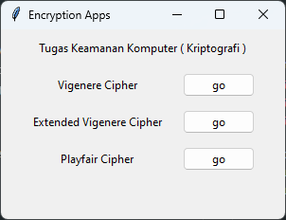

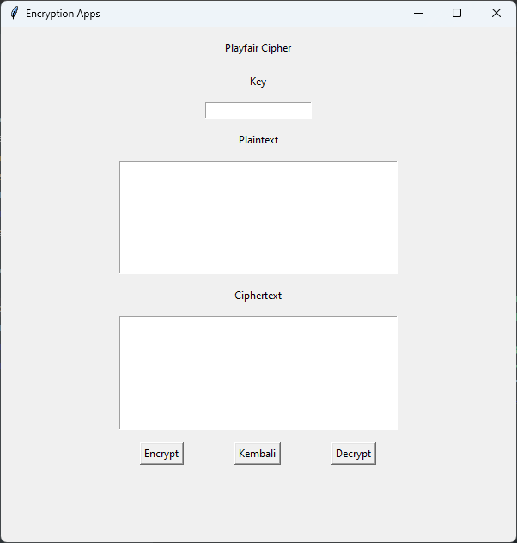

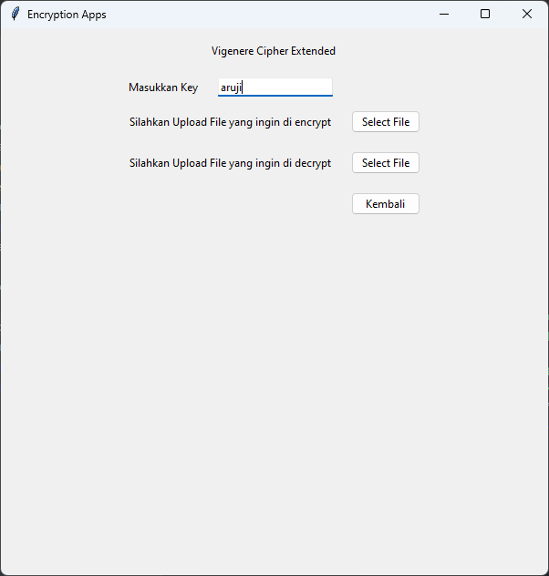

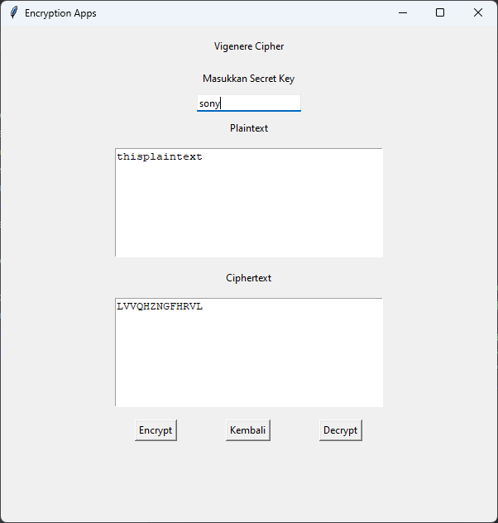

**Contoh plainteks**

Vignere Cipher

* Plaintext
  + Thisplaintext
* Key
  + Sony
* Ciphertext
  + LVVQHZNGFHRVL

Vigenere Extended

* Encrypted File
  + <https://drive.google.com/file/d/1Q2XY3j2mvhq9RFNnZ_jnltSn_NpExRJT/view?usp=sharing>
* Decrypted File
  + https://drive.google.com/file/d/1e73wWmqNPSWH5kr6f4-N6yPTRh51aga5/view?usp=sharing
* Key
* aruji

Playfair Cipher

* Cipher text
  + ZB RS FY KU PG LG RK VS NL QV
* Key
  + JALAN GANESHA SEPULUH
* Plaintext
  + Temui ibu nanti malam

**Source Code**

https://github.com/arudji1211/VigenereAndPlayfairCipher